SEASONAL EMAIL MESSAGES FOR MANGO

February
Spread the Love with Mangos this Valentine’s Day
Valentine’s Day is right around the corner, and mangos make the perfect addition for a day centered around love. If you’re staying in this holiday, including a cup of mangos in your Valentine’s Day spread adds a pop of tropical sweetness at just 70 calories per ¾ cup serving.

Check out a few of our favorite mango dishes that are sure to spark the romance:
- Mango Crostini with Crispy Prosciutto - Combine the ingredients on thin slices of baguette, pop it into the oven to get melty and then top with mango. Not only are these apps tasty, they’re good for you, too.
- Mango, Arugula and Beet Salad - You can’t have a fancy dinner without a little salad. Using one ¾ cup serving of mango ensures you’ll get 50% of your daily value of vitamin C from this flavorful salad.
- Mango Chimichurri Steak - Perfectly seared sirloins topped with a slightly spicy mango chimichurri is certainly the way to some people’s hearts. If you prefer a lighter option, check out one of our many delicious dinner recipes.
- Mango Panna Cotta – To wrap up, try a decadent mango panna cotta. This Italian-style dessert contains three cups of mangos, adding a tropical spin.

Check out the National Mango Board video blog for easy and fun ideas, and keep an eye out for a new how-to video to show how to make a beautiful mango rose! Be sure to follow the National Mango Board on Facebook, Instagram, Pinterest and Twitter for even more mango recipe inspiration.

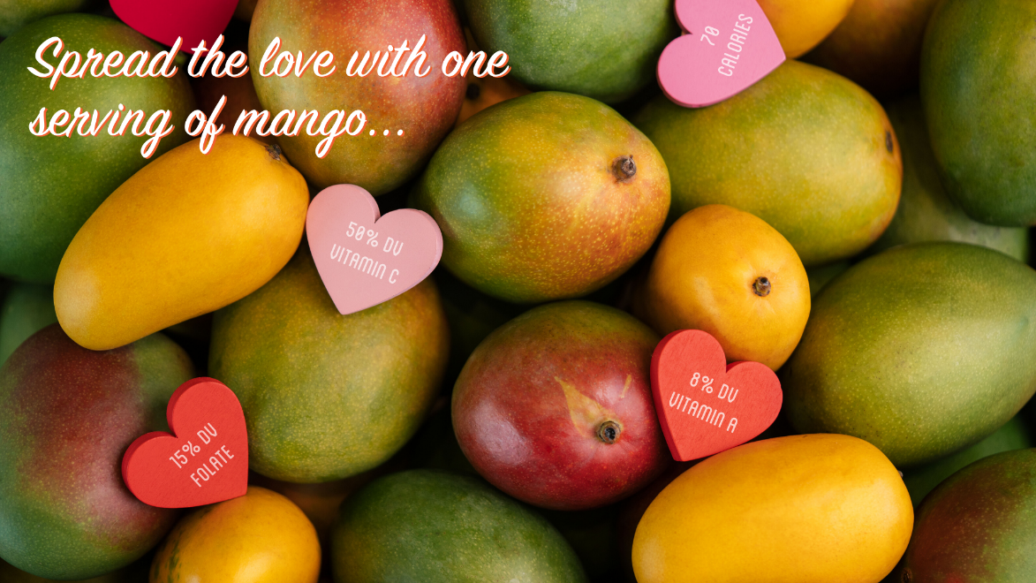

March
Spotlight on Honey Mangos
March is the beginning of Honey mango season, so we’re putting the spotlight on all things golden Honey mangos! The Honey mango or Ataulfo mango originated in Mexico by grower and namesake Ataulfo Morales Gordillo. Because “Ataulfo” isn’t as easy to pronounce this special mango is sometimes called “baby,” “yellow,” and the most popular “honey.” They’re typically labeled as “Honey mangos” in your local grocery store.

The Honey mango is a unique variety when compared to its mango counterparts. It tends to be a bit smaller than other varieties, but it makes up for it in flavor. Honeys are creamy and sweet with no
fibers throughout. They also have a small seed inside, so there’s more mango flesh to enjoy!

In addition to Honeys, the red and round Tommy Atkins and Haden varieties will also reach peak availability in March. Regardless of variety, every mango contains over 20 different vitamins and minerals, and each serving is fat free, sodium free and cholesterol free.

If you’ve now got a hankering for some mangos, check out some recipes that work perfectly with Honey mangos:

- Mango Harvest Wild Rice – This tasty side dish adds a pop of tropical flavor to your traditional wild rice with fresh mango and shredded coconut.
- Grilled Teriyaki Mango Skewers – Is it time to get the grill out yet? These skewers are a fresh and flavorful option for vegetarian or vegan friends.

Check out the National Mango Board video blog for even more fun mango ideas. Be sure to follow the National Mango Board on Facebook, Instagram, Pinterest and Twitter for even more mango recipe inspiration.

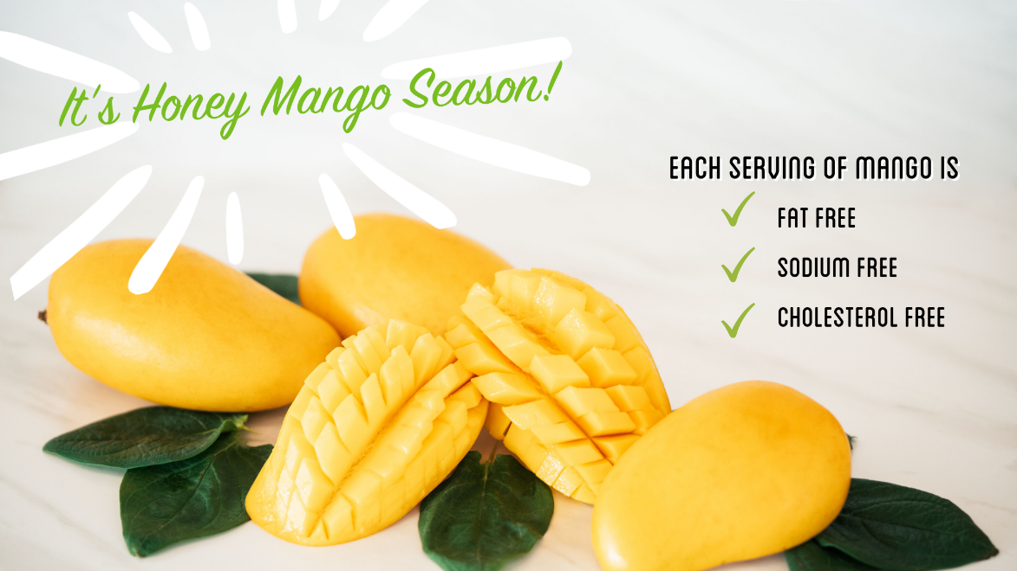

April
Celebrate Cinco de Mango!
Move over Cinco de Mayo. This year, we’re celebrating Cinco de Mango! With four mango varieties in season, it will be easy to add that those tropical vibes to your favorite Mexican dishes. Not only does mango add a pop of flavor, but just one ¾ cup serving of the superfruit contains 50% your daily value of vitamin C.

Here are four delicious mango recipes perfect for your next fiesta, or just dinner at home!
- Tropical Mango Guacamole - Have you worn out your trusty guacamole recipe? Add a mango for a tropical spin on an old favorite.
- Pork Carnitas Tacos with Mango, Tomatillo and Chipotle Salsa – The sweetness from the mango balances with the spicy and savory flavors for a match made in taco heaven!
- Mango Salsa – Just swap out tomatoes for mango to jazz up your standard salsa recipe.
- Grilled Mango and Shrimp Tacos – You’ll go loco for this flavorful and fast meal – you only need 25 minutes from start to finish to whip this up.

For an even simpler mango guacamole recipe, watch us mix up some store‐bought guac with fresh cut mango for an easy last‐minute appetizer.

Be sure to follow the National Mango Board on Facebook, Instagram, Pinterest, Twitter and YouTube for even more mango inspiration.

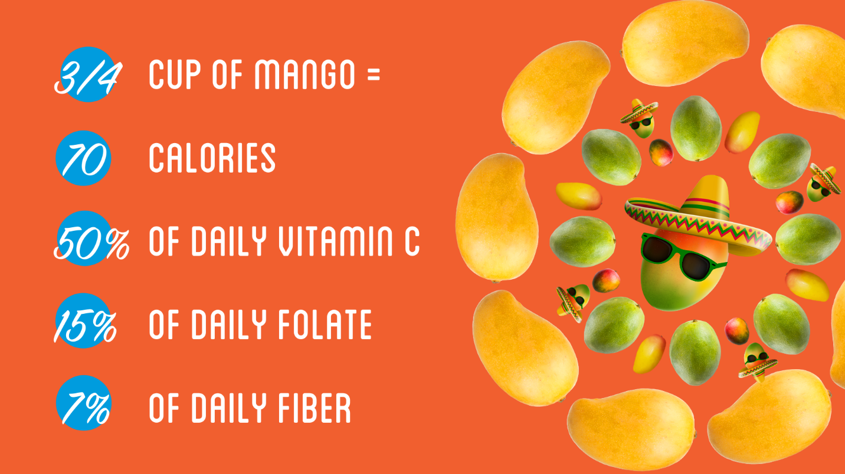

May
Grill up some mangos for a tasty & healthy snack!
It’s time to dust off your barbecues, because it’s grilling season! You’ve probably already grilled pineapples, peaches, or other fruits and veggies, so it’s finally time for mango to shine. Grilling mango halves accentuates those natural sweet and tropical flavors, while adding a smoky caramelization to the fruit.

Mango is the perfect poolside or summertime snack. Each ¾ cup serving of mango has 2 grams of fiber or 7% of your daily needs, which helps you feel full faster after eating. That means you can spend more time with your family and less time feeling hungry!

Need some grilled mango inspo? Look no further! For even more grilled mango recipes, check out the entire collection at Mango.org.
- Grilled Chicken Kabob with Mango Tahini Sauce – These perfectly seasoned chicken kabobs pair with a light and flavorful mango tahini sauce.
- Grilled Mango with Whipped Honey Ricotta Cream – These classic grilled mango cheeks are easy and delicious. Top with a honey ricotta cream and this sure to be a crowd-pleasing dessert.
- Grilled Mango Tacos with Dream Sauce – Grilled mango is the star in these vegan tacos. You won’t be able to get enough of the magical dream sauce made from mango, cilantro, and more.

Be sure to follow the National Mango Board on Facebook, Instagram, Pinterest, Twitter and YouTube for even more mango inspiration.

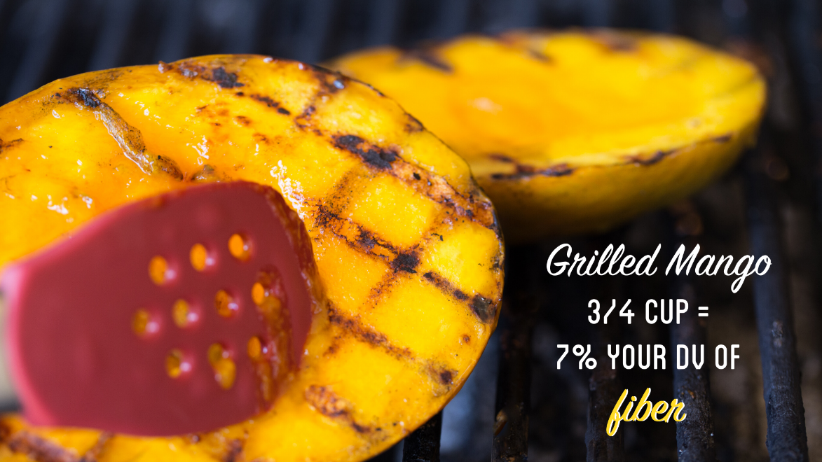

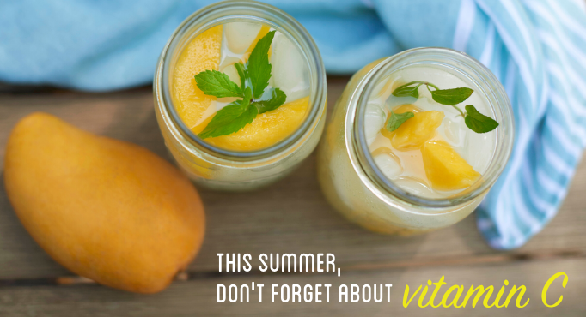

June
Celebrate National Mango Month!
Olé! June is National Mango Month, and we’re celebrating all month long with mango‐licious recipes and some juicy mango jams! Let’s get the party started with some fresh tunes to really set the mango mood. Check out our Spotify playlist for some feel‐good tracks that you’ll be replaying all summer long.

You already know that one ¾ cup serving of mango contains 50% of your daily vitamin C and a host of other vitamins and mineral. But what you might not know is that mango contains a combination of polyphenols and fiber making the fruit good for your gut.

With over 300 recipes, you’re sure to find the perfect recipe at Mango.org. This versatile fruit can be eaten at all mealtimes in both sweet and savory applications. Here are just a few of our favorite types of mango recipes:
- Mango Salsa – Top your fish, poultry or any other dish with a zesty mango salsa. Get five different recipes here for all your dipping or scooping needs.
- Mango Smoothies – It’s hard to have a bad day when you start the morning with a mango smoothie. Whether it’s mixed with bananas, spinach, or berries, it’s sure to be delicious.
- Mango Toast – Easy and flavorful - add fresh mango to your favorite toasts. Our favorite combo is the mango and almond butter.
- Mango Tacos – Mango truly makes the taco. Whether you’re looking for pork, shrimp, vegan or more, we have a taco recipe for you!

Be sure to follow the National Mango Board on Facebook, Instagram, Pinterest, Twitter and YouTube for even more mango inspiration.

July
Mix up some mango relish!
It’s the heat of summer, and you’re probably over all those hot dogs and hamburgers at every backyard barbecue. We’ll probably always eat these summertime American staples, but we have an idea on how to jazz them up: mango relish.

With some no‐cook versions and just a few ingredients, mango relish is an easy way to knock the socks off your summertime party guests. And don’t forget – with 50% of your daily vitamin C, a serving of mango is the perfect no‐guilt topping.

Here are a few mango relish recipes to top your grilled brats or charcuterie boards:
- Mango Curry Relish: With just five ingredients, this mango curry relish is super easy to whip together. The sweetness from the mango is cut by delicious curry and lime flavors.
- Mustard Mango Relish: Step aside yellow mustard. All you need to do is combine fresh mango, grain mustard, sugar and thyme in a bowl, and add salt and pepper to taste.
- Pickled Green Mango Relish: This sweet and spicy pickled green mango relish uses unripe mango to add a zesty tang. This relish is perfect for a variety of summer dishes including roasted meats, grilled seafood, or a garnish for hor d’oeuvres like deviled eggs.

Be sure to follow the National Mango Board on Facebook, Instagram, Pinterest, Twitter and YouTube for even more mango inspiration.

